Show off your Ugly Christmas Sweater

At this year’s Ugly Christmas Sweater Contest
Do you have the tackiest, most festive, or most creative Christmas sweater?
Let us be the judge!

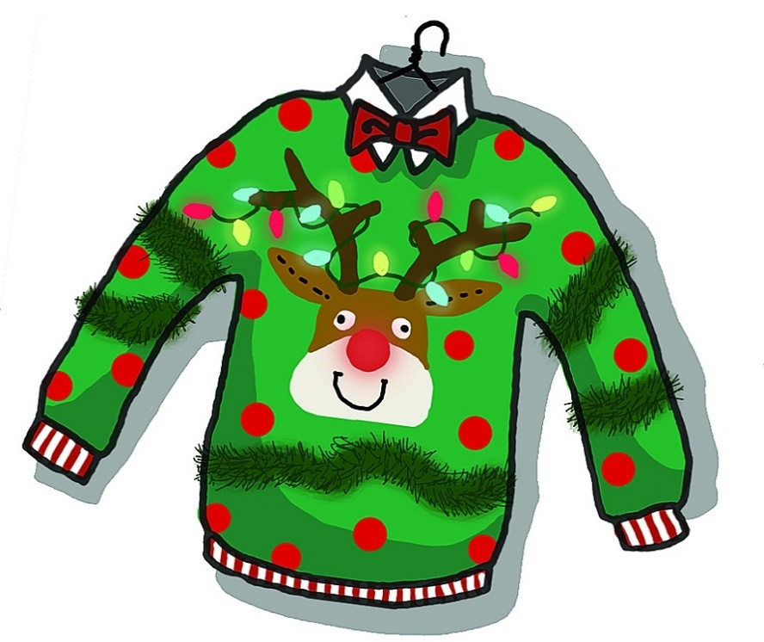

Only $1.00 to enter!

The competition will be held on Friday, December 13th.

1st, 2nd, and 3rd place winners announced for each group.

Concessions will be sold for $1.

