Show off your Ugly Christmas Sweater

At this year’s Ugly Christmas Sweater Contest
Do you have the TACKIEST, most FESTIVE, or most CREATIVE Christmas sweater?
Let us be the judge!

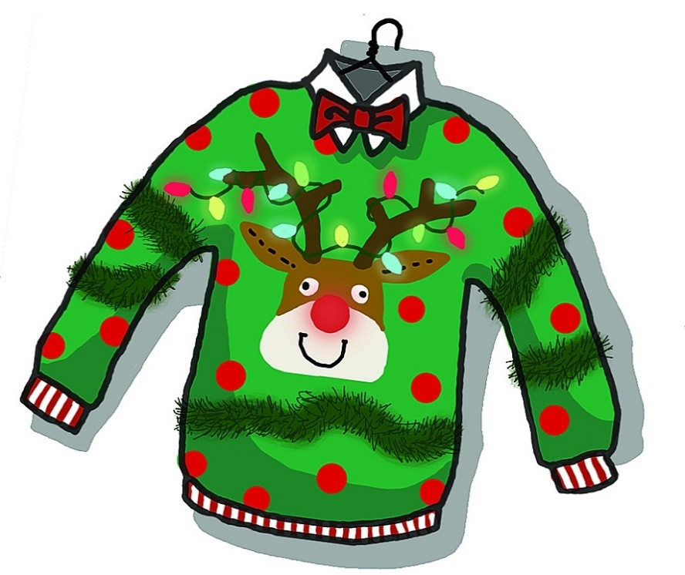

Only $1.00 to enter!

The competition will be held on Friday, December 14.

The top two winners will receive a cash reward!

Concessions will be sold.

