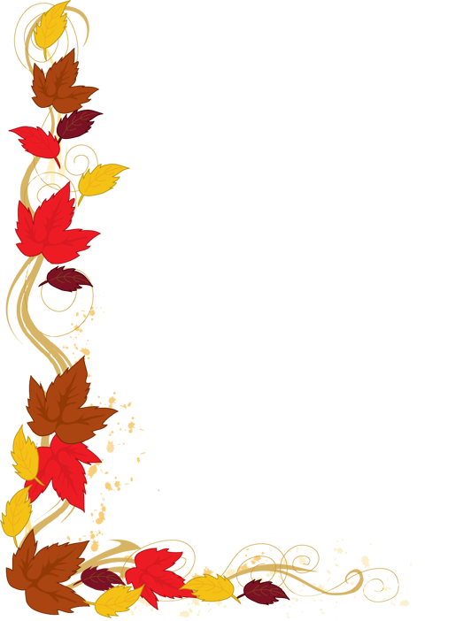
Fall Pictures Info

Fall pictures will be taken on
August 21, 2018 by Bill Miller Photography.

Fall retakes will be taken on October 17, 2018.

