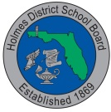

Public Review of Instructional Materials:

Holmes District School Board is in the process of reviewing Kindergarten through fifth grade Social Studies materials that are up for adoption.

Please log in to the following website to review state recommended Social Studies materials for the 2016-2017 adoption period.

https://app2.fldoe.org/BII/InstructMat/Evaluation/Account/Login.aspx

