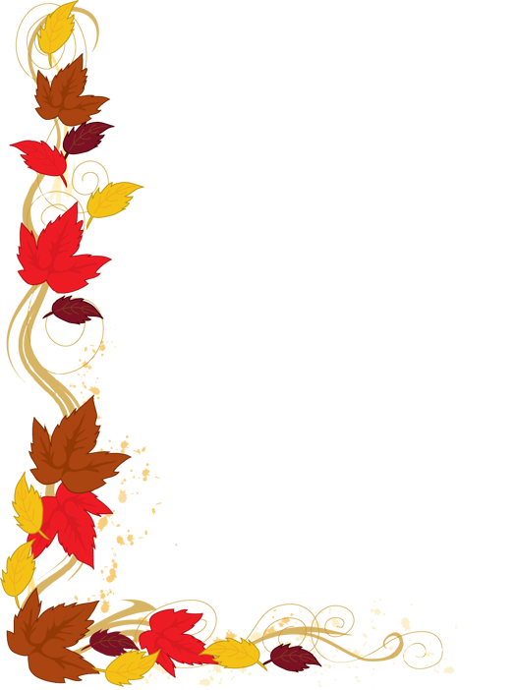
Fall Pictures /Senior Portraits Info

August 21, 2018: Fall pictures
*Senior formal with 3 outfits ($25.00 sitting fee)

October 17, 2018: Fall retakes
*Senior formal only

***Regarding Senior Portraits***
For a $25.00 sitting fee, you can have pictures taken with 3 outfits in addition to your formal drape/tux pictures. You will receive a proof book to order from. This proof book must be turned back in. If you do not pay the $25.00 you will not receive a proof book or have the opportunity to have the pictures taken with 3 outfits – only senior formal pictures will be taken.

