P S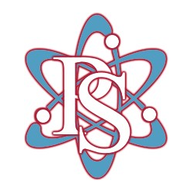H S

2018 Atomics Middle School Baseball
Date | Opponent | Location | Time
2/10 | Red & Blue | Home | 10:00
2/13 | (Preseason) Bonifay (DH) | Away | 4:30
2/16 | Bethlehem (DH)* | Away | 4:00
2/24 | Bethlehem (DH)* | Home | 11:00
2/26 | Paxton | Away | 4:00
2/27 | Graceville | Away | 4:00
3/3 | PDL (DH)* | Home | 11:00
3/6 | PDL (DH)* | Away | 4:00
3/10 | Conference Tournament | PDL | 11:00/1:00
*Conference Opponents Head Coach: Travis Moseley

